Warsaw, 29 September 2025
Press release
Almost 29,000 listeners attended the 15th La Folle Journée de Varsovie “City Vibrations”
26–28 September 2025
Teatr Wielki – Polish National Opera (pl. Teatralny 1)
Concert Pavilion on Teatralny Square
Church of Art Societies (18b Senatorska Street)
The 15th edition of La Folle Journée de Varsovie, held under the motto City Vibrations, has come to a close. In just three days, 57 concerts were presented across six stages – at the Teatr Wielki – Polish National Opera, the Church of Art Societies, and in the Concert Pavilion on Teatralny Square. Nearly 1,000 performers, 15 chamber ensembles, 18 conductors and 14 orchestras – including nine youth orchestras from Polish music schools – took part. This year’s festival drew an audience of almost 29,000.
Symphonic concerts, chamber music, solo recitals… Alongside masterpieces of the 18th, 19th and 20th centuries, the 15th La Folle Journée de Varsovie featured traditional sounds, early music, premieres and first performances of contemporary works, as well as jazz. There were also attractions for the youngest audiences. The orchestras performing included Sinfonia Varsovia, the Polish Radio Orchestra in Warsaw, the Orchestra of the Teatr Wielki – Polish National Opera and the Warsaw Philharmonic Orchestra, under the batons of Jean-François Verdier, Grzegorz Wierus, Ewa Strusińska, Bar Avni, Christian Arming, Patrick Fournillier, Wojciech Rodek and Michał Klauza. Soloists and recitalists included Yuto Kiguchi (piano), Seina Matsuoka (violin), Waed Bouhassoun (oud, voice), Neşet Kutas (percussion), Ania Karpowicz (flute), Sotiris Athanasiou (guitar), Jean-Frédéric Neuburger (piano), Momo Kodama (piano), Aleksandra Olczyk (soprano), Monika Ledzion (mezzo-soprano), Emmanuel Balssa (viola da gamba), Katarzyna Drogosz (historical piano), Luka Faulisi (violin), Trey Lee (cello), Maciej Kułakowski (cello), Julien Beautemps (accordion), Pierre Hantaï (harpsichord) and Martín García García (piano). The line-up also featured ensembles such as Quatuor Ellipsos, Quatuor Elmire, TVÆRS, the Paul Lay Trio, Ensemble Maru, the Martin String Quartet, the Chopin University Big Band, the Deaf Percussion Orchestra, Aka Duo and Duo Argos, as well as early music groups Arte dei Suonatori, Capella Cracoviensis and Oltremontano.
As part of the Young Performers cycle, school ensembles from across Poland took to the stage: dancers from the Roman Turczynowicz General Ballet School in Warsaw, and orchestras from Warsaw (Karol Szymanowski State Music Schools Complex No. 4, Zenon Brzewski Secondary Music School – State Music Schools Complex No. 1), Białystok (Ignacy Jan Paderewski Music Schools Complex), Katowice (Karol Szymanowski State Secondary General Music School), Bielsko-Biała (Stanisław Moniuszko State Music Schools Complex), Gdańsk (Feliks Nowowiejski General Music School I and II Level), Wrocław (Karol Szymanowski Primary and Secondary Music School) and Kraków (Bronisław Rutkowski State Primary and Secondary Music School, Mieczysław Karłowicz State Music Schools Complex).
A remarkable undertaking
For 15 years, La Folle Journée de Varsovie has thrived not only thanks to its artists, but also to the hundreds of people working tirelessly behind the scenes. The festival means countless hours of preparation, piles of contracts and invoices, and kilometres covered during the event. It also means posters, billboards and advertising campaigns across the city, in cinemas, trams, on the radio and online, as well as thousands of printed programmes. Each year, the Sinfonia Varsovia team – both permanent staff and those engaged specially for the festival – including producers, stage managers, technicians, piano tuners, members of the operations, marketing, stage and front-of-house teams, box office staff, artist liaisons, the print team, photographers, impresarios and programme coordinators, security staff, as well as volunteers, the directing team from the Academy of Film and Television recording the Young Performers concerts, dozens of drivers and logistics staff, and tutors accompanying the visiting school ensembles – all contribute to the organisation of the festival. Their work is a reminder of the vast organisational machinery that brings La Folle Journée de Varsovie to life.
***
La Folle Journée de Varsovie is the Polish edition of the international La Folle Journée festival, launched in 1995 in Nantes. It was created on the initiative of Sinfonia Varsovia – the orchestra that has been part of the festival in France from the very beginning and has also performed in many of its Japanese, Russian and Spanish editions. Each year, on the last full weekend of September, thousands of listeners gather at the Teatr Wielki – Polish National Opera in Warsaw to choose from dozens of concerts within just a few days. La Folle Journée de Varsovie was one of the first festivals in Poland to combine recitals, symphonic and chamber concerts by leading international artists with an extensive educational programme.
***
Artistic Director of La Folle Journée festival: René Martin
Honorary Patronage: Embassy of France in Poland
Organisers: Sinfonia Varsovia and the City of Warsaw (a cultural institution of the Capital City of Warsaw)
Co-organisers: Ministry of Culture and National Heritage, National Institute of Music and Dance, Teatr Wielki – Polish National Opera, Centre for Artistic Education, Ogrody Muzyczne Foundation, CRÉA Folles Journées, Capital City of Warsaw
Main Sponsor: ORLEN
Sponsor: PGE Polska Grupa Energetyczna
Main Partner: Zygmunt Zaleski Stichting
Strategic Partner: Totalizator Sportowy
Partners: Orange, Institut français de Varsovie, Music Is For Everyone Foundation (Fundacja Muzyka jest dla Wszystkich), Mazowsze. Serce Polski
Supported by: Sinfonia Varsovia Foundation, City of Nantes, Art Music Denmark, Daegu Concert House
Media Partner: Ruch Muzyczny
Media Patrons: Onet, RMF Classic, Polityka

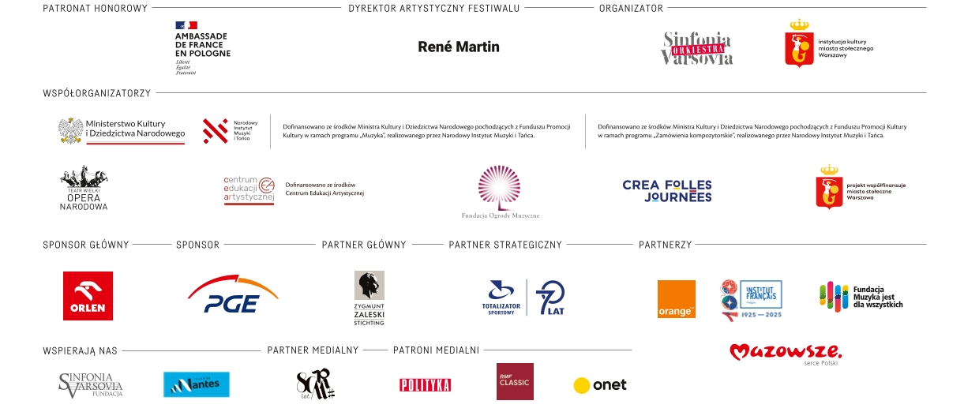
***
Kontakt dla mediów:
Florent de Bazelaire
Senior PR and International Relations Specialist
Sinfonia Varsovia, Marketing and Audience Services Department
florentyn.bazelaire@sinfoniavarsovia.org, tel. + 48 691 115 919‬‬‬‬‬‬‬‬‬‬‬‬‬‬‬‬‬‬

Adrianna Michalska
Senior PR Specialist
Sinfonia Varsovia, Marketing and Audience Services Department
adrianna.michalska@sinfoniavarsovia.org, tel. +48 502 243 387‬‬‬‬‬‬‬‬‬‬‬‬‬‬‬‬‬‬

